MP Events, in association with Longwood Harriers AC present

The 26th Joe Percy Invitation 10K

Wednesday 14th June 2023 Start Time 7.15 p.m. Note earlier start time please

Storthes Hall Ln, Kirkburton, Huddersfield HD8 0WA

Entries
Team lists must be submitted by Thursday 1st June at the latest and unfortunately, we cannot accept any late entries or changes. The entry fee is £10.00 per runner. Minimum age is 15 years.
This year we have a club limit of 50 runners due to the ever-expanding popularity of the race and increasing number of clubs forming. We also would appreciate it if each club could supply 2/3 volunteers or marshals to help us put on a safe event. Volunteers will need be at the event HQ by 6pm to be given their race brief and volunteer role. Please email mattpatt@hotmail.co.uk with your clubs' volunteers by June 10th 2023 thank you.
Team entry fees should be made by BACS payment, by Thursday June 1st to the following account number: - Sort Code 53-61-07 Account No: 24105082 Matthew Pattison. Please add your club's name as a reference.
On the night, there will be a box for each Club’s teams at the Venue, this will contain race numbers which will incorporate the timing chip, for issuing to your team members and the up-to-date team list which must be signed by all team members and returned to the entry table by 19.00 Please do not swap entries with pre-entry no shows.
For 2023 to try and ease congestion in the race HQ, I have allocated a room, or a section of the stands for your teams to assemble and collect numbers, locations for each club will be displayed at the main entrance to the Stafflex Arena on the day.
If your club would like some extra spaces, please contact me ASAP to see if I can allocate you some unused places from other clubs.

Results
Live timing of the event will be provided and online results will be displayed at www.timemyrace.co.uk

Presentation
The three team prizes and winners' trophies for Men's and Ladies Teams will be presented as soon as possible after the race, either in the Venue if the weather is bad, outside the bar area. Please ensure your team are aware that we provide catering (for competitors only) at the Venue prior to the presentation.

Facilities
The Bar will be open.
We will provide for all runners some food, with a vegetarian option too. – This year we will be using the on-site caterers.
Toilets are available on site. No showers but changing facilities will be available
Car parking is available on-site and will be sign posted. Please car share where possible and park considerately. Please do not park on the left-hand side above the exit on Storthes Hall Lane as this makes it dangerous for returning runners
Directions
The postcode is HD8 0WA and the complex can be reached from Huddersfield by following the A629 Penistone Road and turning right onto Storthes Hall Lane shortly after passing the traffic lights by the White Swan.

Start and Finish
The race start and finish has been moved to Wood Lane (a short walk from the HQ) for 2023 and the HQ is located in the Shelley FC complex.
Please also do not use any of the private land as a make shift toilet as we need to keep the owners on our side for future events!!
Locating the start and finish close to the HQ has enabled us to start slightly earlier than previously at 19.15.

The Course
Course map https://www.strava.com/routes/3007063215760955894
The course has changed slightly so please note!! The Start/Finish is now on Wood Lane, not Storthes Hall Lane which is a gentler climb to the Joe Percy loop and we enter the loop at a different point so please listen to our marshal’s instructions. Once on the usually loop please stay left at all times until you have completed 2 loops and are directed to move over to the right to run back down Wood Lane to the finish.
Marshals will be in place but please be aware that traffic may not be as patient as we runners are. The Course will be using the original Farnley loop and not the adjusted one in my previous emails.
At the end of the second lap, on reaching Wood Lane junction, runners will be directed across the road and remain on the right to the top of Wood Lane, please do not anticipate this crossing point and attempt to cross early, wait till you reach the marshals and follow their instructions.
On turning right down Wood Lane, runners can use the whole of the road as it will be closed to traffic until the finish of the race. ONLY WOOD LANE IS CLOSED TO TRAFFIC PLEASE BE CAREFUL ON THE REST OF THE ROUTE!
Although the course has little traffic, concern has been expressed by Kirklees Council and Highways that runners will be competing on a live road, therefore runners must remain fully aware of the dangers that this may present and keep close to the kerb, particularly on the narrow section of Farnley Rd leading into the village. In addition, the course has been measured using the shortest line, which includes running on the pavement from the bollards at the start of Butts Road through to Butts Close in Farnley Tyas village.
In accordance with Rule 240 S5 of UKA Competition Rules 2016 – 2018, runners must not wear any form of music playing device as they must be able to hear instructions from marshals and be aware of traffic, failure to comply with this rule will result in withdrawal from the race or removal from results.

Parking
This year parking will be on the fields surrounding the Shelley FC site, please listen to our car park marshals and when leaving please be careful of runners still finishing.

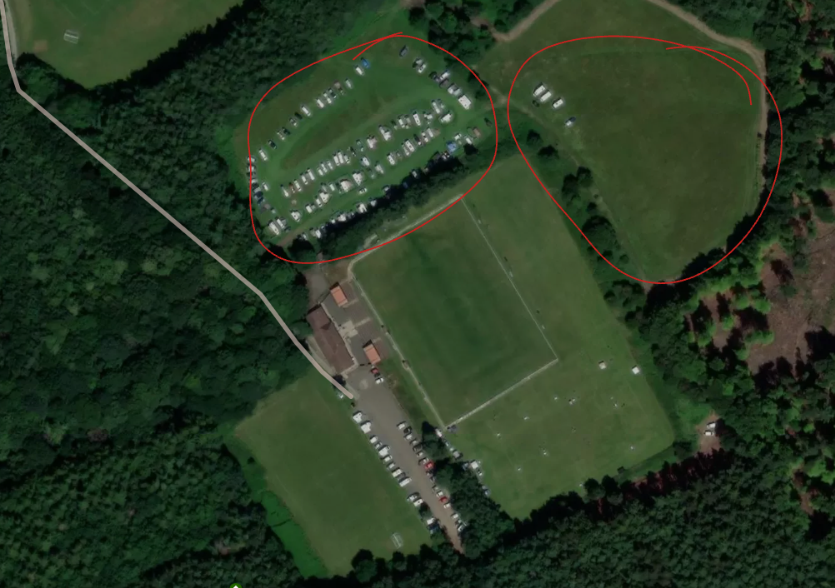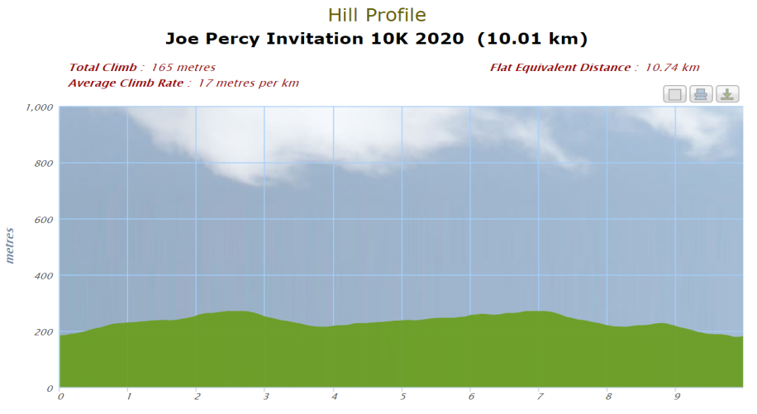

Revised start and finish
Wood Lane not Storthes Hall Lane
New route for 2023 and onwards
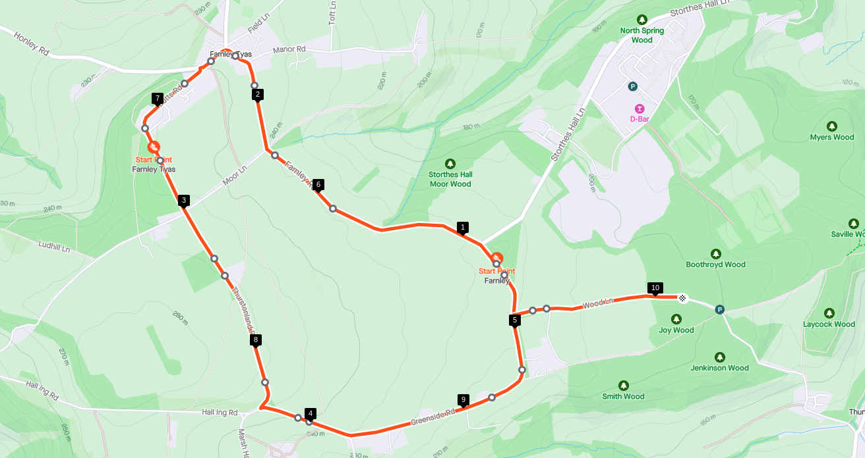

Club ______________________________________________________________________
Race No: | Full Name | M/F | Age | Veg | Signature

